

**Audio Visual Control System**

**Level 24 Airlock**

**User Manual**



© 2016 Corporate Initiatives Australia Pty Ltd

Contents

Welcome 3

Starting the system 3

Laptop Presentation 4

Wireless Presentation 4

Foxtel 6

Foxtel Controls 6

Display Selection 7

System Shutdown 8

Automatic Shutdown 8

Settings (technical users) 9

Schedule 9

Change Code 10

# Welcome

The audio-visual system employs the use of a dedicated Crestron touch panel and an Apple iPad running Creston App to control audio visual devices within the system. Operation is done by touching the screen.

# Starting the system

This **Start** page is the starting point for the system. You should see this page when you first approach the touch panel, otherwise touch anywhere on the screen to wake up the display. Touch the central box to start the display and use the system.

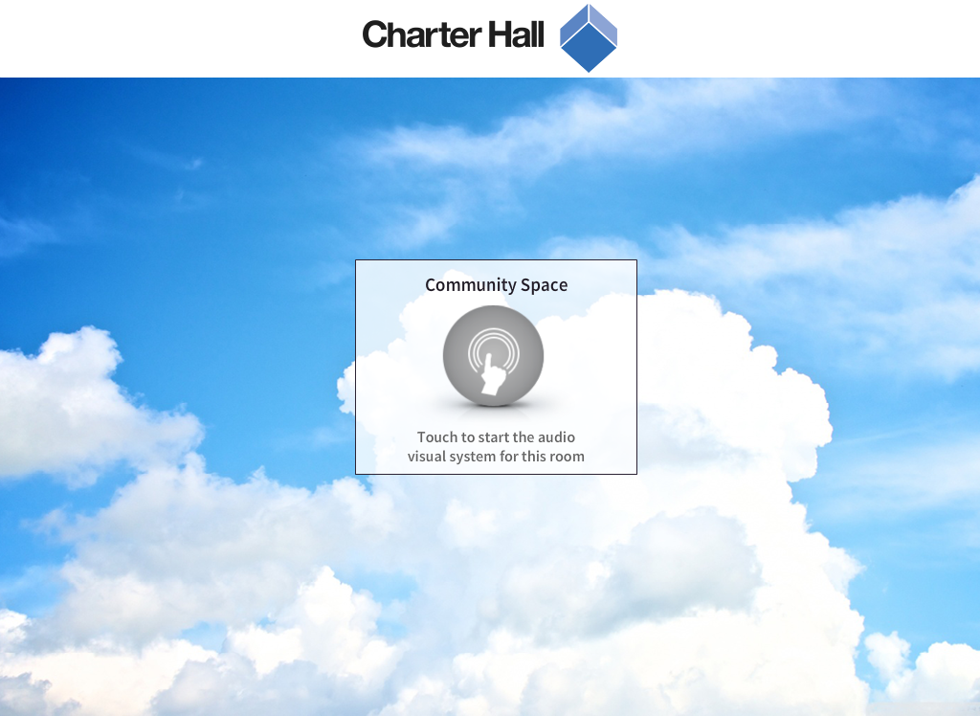

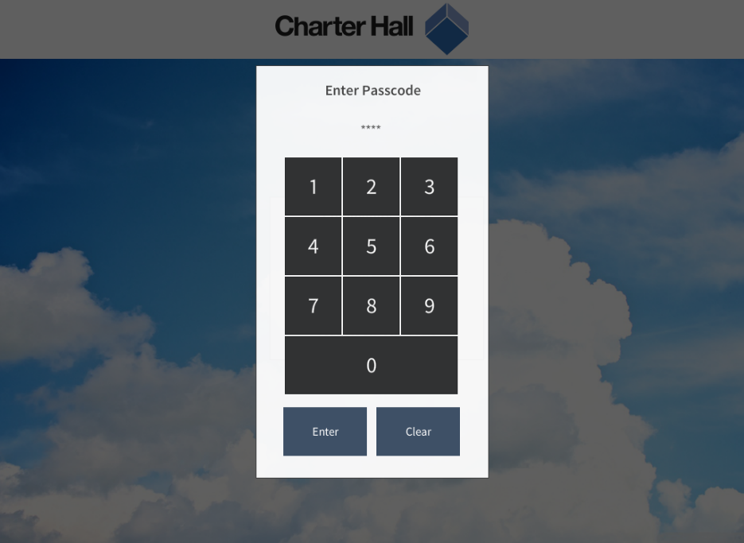The system will prompt you to enter a code to start the system. Enter the correct code to continue.

# Laptop Presentation

The system will default to Laptop Presentation mode after a normal startup This mode allows you to plug in a laptop into the wall plate using a HDMI cable.

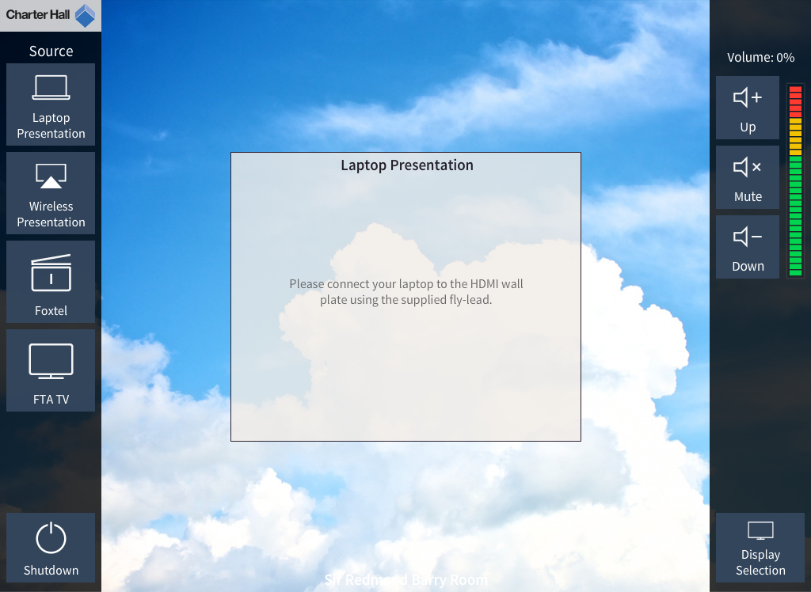

Source selection

Audio level adjustment

# Wireless Presentation

Touch here to open the shutdown confirmation popup.

After pressing the Wireless Presentation source button, the wireless presentation device will be shown on screen with instructions on how to connect to the system.

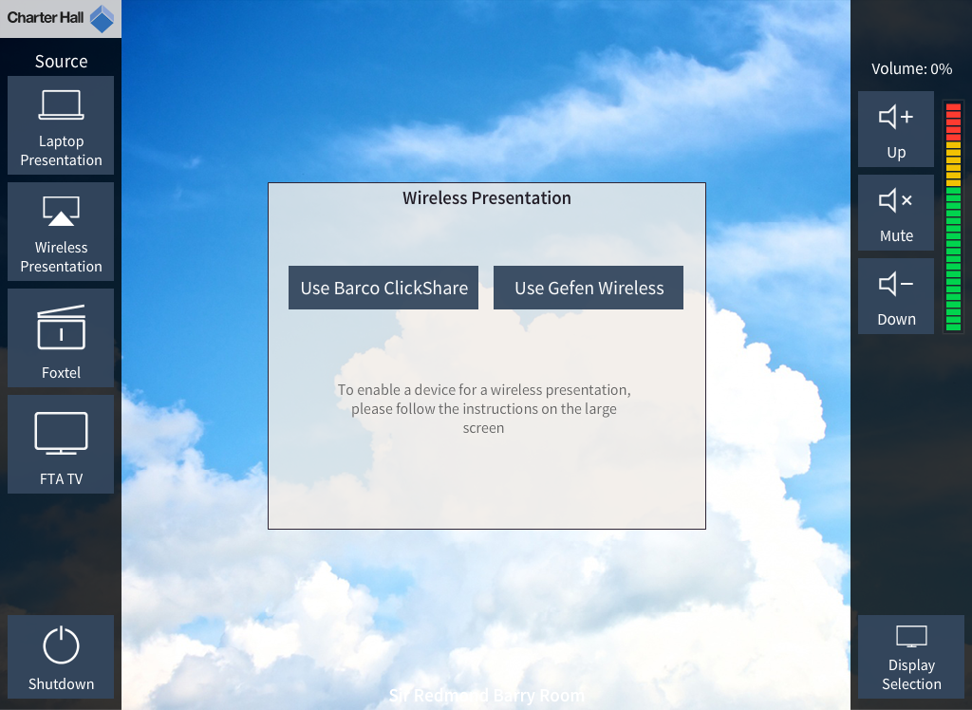

# Foxtel

. This mode allows you to view live television stations. There are 2 subsections in this mode:

* Stations – Allows you to select from 15 preset stations.
* Controls – Allows you to navigate the on screen menu’s of the TV set top box.

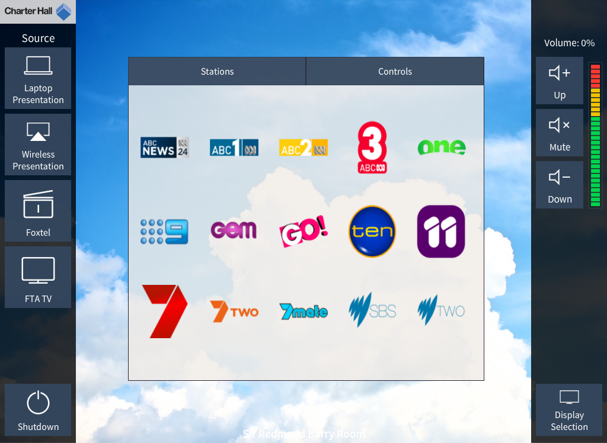

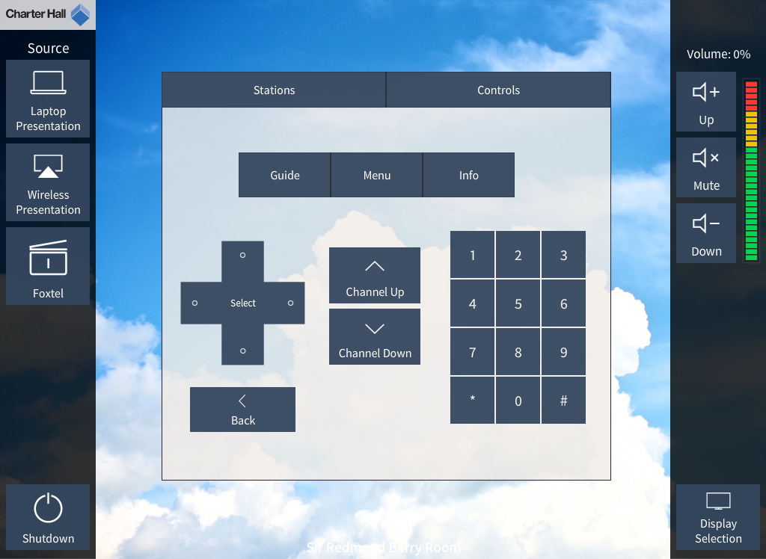

## Foxtel Controls

Use the controls on this subpage to navigate around the on-screen menus of the set top box. You may view the electronic program guide by pressing the Guide button and then using the arrow buttons and select to choose a desired program. Alternatively, enter the station number directly using the keypad

# Display Selection

If you wish to change the current actively used display, press the Display Selection button to bring up the Display Selection popup. Choose a display to use.

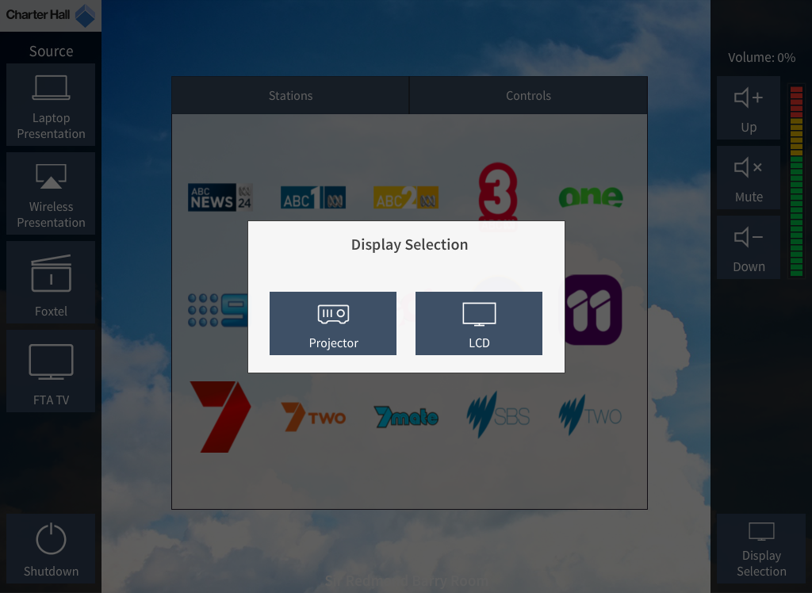

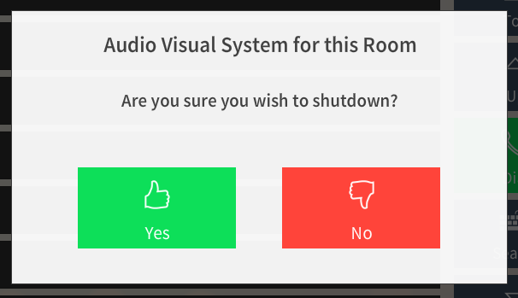System Shutdown

After pressing the Shutdown button, a confirmation popup will appear for the user to confirm system shutdown. Pressing Yes will commence the shutdown sequence where pressing No will dismiss the popup and continue normal use.

## Automatic Shutdown

If automatic shutdown is enabled within the settings menu, a prompt will appear and display for 30 minutes before shutting down the system. A user may cancel the shutdown by pressing the Cancel shutdown button.

# Settings (technical users)

To access the settings menu, press and hold the Charter Hall logo in the top left of the main page for 5 seconds. A passcode popup will appear. Enter the correct administrator code to gain access.

## Schedule

The schedule section allows the system to be configured so it automatically turns on at the start of each day or automatically turns off at the end of each day. Follow the steps below:

1. Select the event – Either ‘System On’ or ‘System Off’
2. Set the time that the system should turn on or shutdown at
3. Select the days you wish for this to take place
4. Select Save

Once saved you can repeat these steps to adjust the schedule when necessary.

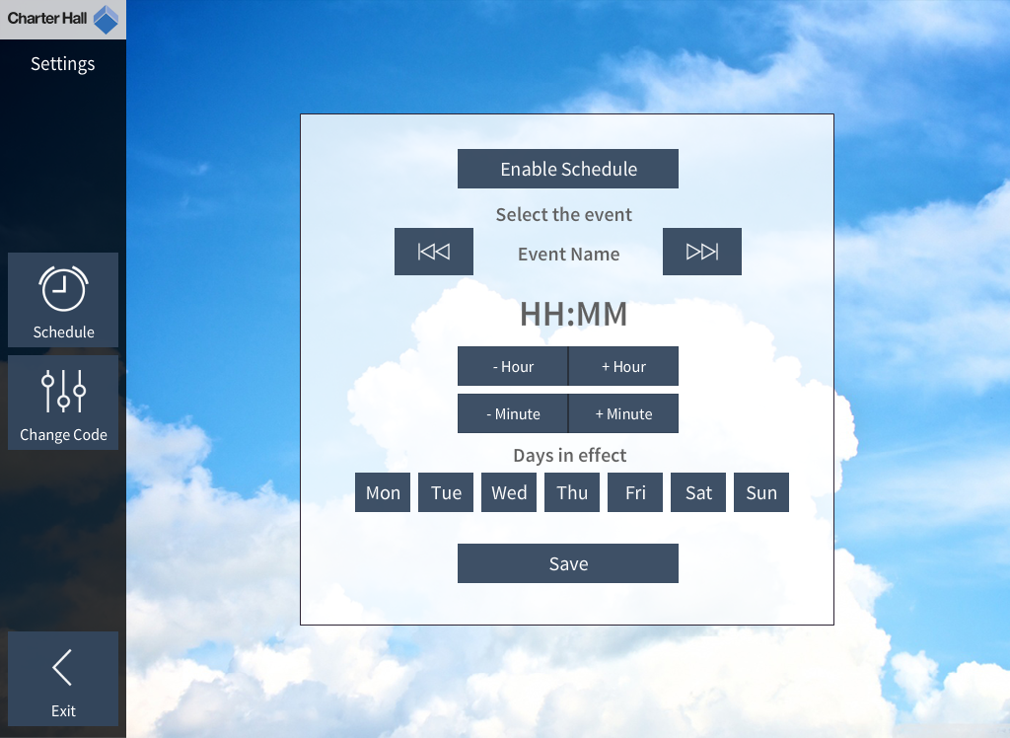

## Change Code

This section allows an administrator to change either the user code (to start the system) or the admin code (to access the settings or start the system). Select which code to change first and then enter a new code followed by Enter to change a code.

